Design and Implementation of High-Performance
FIR Filter for Real-Time Audio Signal Processing
A Project Based Learning Report Submitted in partial fulfilment of the requirements for the award of the degree

of

Bachelor of Technology
in The Department of Electronics and Communication Engineering
23VLS3303A and VLSI PHYSICAL DESIGN AUTOMATION
23SDEC18A and VLSI SUBMICRON DESIGN AND VERIFICATION
23VLS3202R and TESTING AND VERIFICATION OF VLSI CIRCUITS

Submitted by
2310040023: K. Yasawini
2310040072: G. Akshaya
2310049146: Kashifa Konain

Under the guidance of
Dr. Kasi Bandla, Dr. Kayam SaiKumar & Dr. N. Phalguni Singh


Department of Electronics and Communication Engineering
Koneru Lakshmaiah Education Foundation, Aziz Nagar
Aziz Nagar – 500075
JAN - 2025.

INTRODUCTION

Digital signal processing has become an essential part of modern audio systems, enabling applications such as hearing aids, mobile communication devices, smart speakers, medical instruments, and real-time audio monitoring systems. One of the most important operations in audio signal processing is filtering, which is used to remove noise, enhance signal quality, and extract useful frequency components. Among various digital filters, Finite Impulse Response (FIR) filters are widely used due to their inherent stability, linear phase response, and predictable behavior, making them ideal for high-quality audio processing applications.
Real-time audio processing systems demand extremely low latency and high throughput. In delay-sensitive applications like hearing aids, even a few milliseconds of delay can degrade the user experience and affect speech intelligibility. Software-based filtering techniques typically introduce latencies ranging from 10 to 50 milliseconds, which is unacceptable for such real-time systems. Additionally, modern audio standards operate at sampling rates between 48 kHz and 192 kHz, requiring the filter to process a large number of samples every second. These requirements make it necessary to design hardware-based solutions that can handle high-speed processing with minimal delay.
Field Programmable Gate Arrays (FPGAs) provide an effective platform for implementing real-time digital signal processing algorithms. Their parallel processing capability and configurability allow designers to achieve high performance while maintaining flexibility. However, implementing FIR filters on hardware is not straightforward. High-order filters require multiple multiply-accumulate operations, which can lead to increased resource usage, higher power consumption, and longer critical paths. These issues are especially important in portable and battery-operated devices, where power efficiency and optimal resource utilization are crucial.
Another major challenge in high-speed FIR filter design is meeting strict timing constraints. As clock frequencies increase beyond 100 MHz, critical path delays in arithmetic operations can prevent the design from achieving timing closure. Timing violations can result in unreliable system behavior and data corruption. Therefore, careful architectural planning and thorough Static Timing Analysis (STA) are essential to ensure reliable operation. STA helps in analyzing setup time, hold time, clock-to-Q delay, and slack, allowing designers to identify and optimize timing bottlenecks.
This project focuses on the design and implementation of a high-performance, resource-efficient FIR filter for real-time audio signal processing applications. A 16-tap FIR filter is implemented using Verilog Hardware Description Language (HDL), providing precise control over hardware behavior and timing. To achieve high throughput and low latency, a pipelined architecture is adopted. Pipelining divides the computation into multiple stages, reducing critical path delays and enabling the filter to operate at higher clock frequencies.
In addition to architectural optimization, comprehensive Static Timing Analysis is performed to ensure timing closure at the target operating frequency of 100 MHz or higher. Performance metrics such as latency, throughput, and resource utilization are carefully evaluated and optimized. Functional verification is also carried out to ensure correct operation and validate that the frequency response meets the desired specifications. Overall, this project presents an efficient and reliable approach to designing high-speed FIR filters, making it suitable for real-time audio processing and advanced digital signal processing applications.

LITERATURE SURVEY

I.2.1 FIR Filters in Real-Time Audio Signal Processing
Finite Impulse Response (FIR) filters are widely adopted in real-time audio signal processing applications due to their guaranteed stability and linear phase response. Literature highlights their importance in systems such as hearing aids, speech enhancement, and audio equalization, where signal distortion must be minimized. However, prior studies report that increasing the number of taps in FIR filters leads to higher computational complexity, increased latency, and greater hardware resource usage. These challenges make optimized hardware-based FIR filter design a key research area.

II.2.2 FPGA-Based FIR Filter Implementations
Research comparing software-based and hardware-based FIR filter implementations indicates that software solutions suffer from significant latency, making them unsuitable for real-time audio systems. FPGA-based implementations offer parallel processing, reconfigurability, and high-speed operation, enabling low-latency and high-throughput filtering. However, literature also notes that poorly optimized FPGA designs can result in excessive use of LUTs, DSP blocks, and registers, leading to increased power consumption. Hence, architectural optimization is critical.

III.2.3 Pipelined FIR Filter Architectures
Pipelining is a commonly used technique to enhance the performance of FIR filters by reducing critical path delays. Studies show that inserting pipeline registers between multiply-accumulate (MAC) stages allows FIR filters to operate at higher clock frequencies while maintaining stable performance. Pipelined architectures are particularly effective in achieving throughput greater than 100 MSPS. However, excessive pipelining can increase latency and area, requiring careful design trade-offs to balance speed, power, and resource utilization. 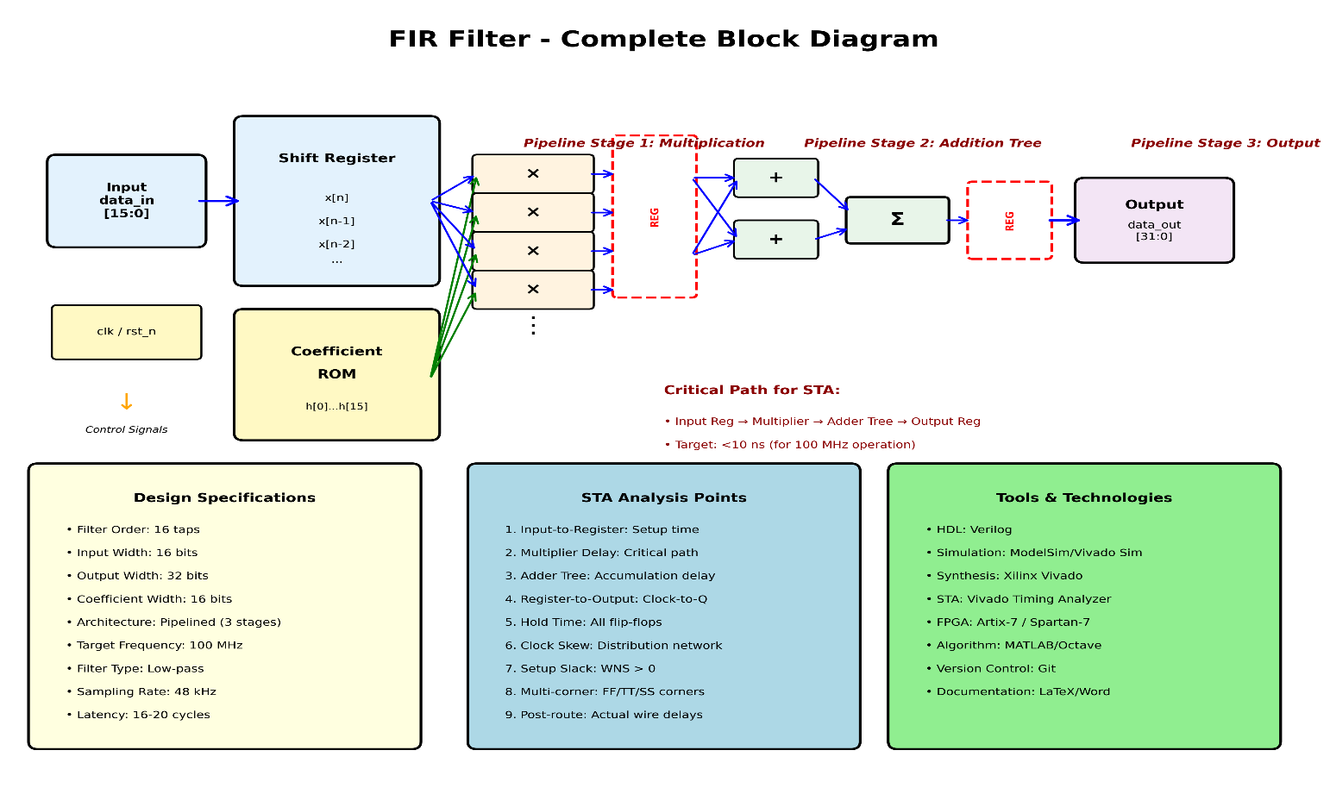

IV.2.4 Resource Optimization Techniques in FIR Filters
Several research works focus on reducing hardware complexity in FIR filter implementations. Techniques such as coefficient symmetry, distributed arithmetic (DA), and multiplier-less architectures have been explored to reduce the number of multipliers. While DA-based approaches lower multiplier usage, they may increase memory requirements and reduce scalability. Recent literature favors pipelined multiplier-based architectures, as they provide a better balance between performance, scalability, and design simplicity for real-time applications.

V.2.5 Static Timing Analysis in High-Speed FIR Designs
Static Timing Analysis (STA) plays a vital role in ensuring reliable operation of high-speed FIR filters. Prior research emphasizes that timing violations, including setup and hold failures, become more prevalent at higher clock frequencies due to long combinational paths in MAC operations. STA enables analysis of setup time, hold time, clock-to-Q delay, and slack without dynamic simulation. Literature strongly recommends timing-driven optimization to achieve timing closure in high-performance FIR designs.

VI.2.6 Methodology
Based on insights from existing literature, the methodology of this project focuses on timing-driven FIR filter design. Initially, a 16-tap FIR filter is modeled using Verilog HDL and synthesized to generate a gate-level representation. A pipelined architecture is implemented to reduce critical path delays and support high-speed operation. Following synthesis, Static Timing Analysis is performed to evaluate setup time, hold time, clock-to-Q delay, and register-to-register path delays. Critical timing paths are identified, and design optimizations such as pipeline balancing and logic restructuring are applied to achieve positive timing slack. Functional verification and frequency response validation are then carried out to ensure correct operation.

VII.2.7 Expected Outcomes
The expected outcome of this project is a high-performance FIR filter capable of operating at clock frequencies of 100 MHz or higher while maintaining low latency and high throughput. Timing violations are expected to be eliminated through comprehensive STA, resulting in positive setup and hold slack across all critical paths. Resource utilization is optimized to minimize power consumption while preserving performance. The final design is anticipated to demonstrate reliable real-time audio filtering with verified functional and timing correctness.

VIII.2.8 Future Scope
Future work can extend this design to higher-order FIR filters and adaptive filtering applications such as noise cancellation and echo suppression. The methodology can be applied to multi-clock domain designs and advanced FPGA architecture. Further optimization techniques, including power-aware pipelining, clock gating, and low-power clock tree design, can be explored. Additionally, the design can be integrated into complete audio processing pipelines or extended toward ASIC implementation for ultra-low-power real-time applications.

REFERENCES

[1] J. G. Proakis and D. G. Manolakis, Digital Signal Processing: Principles, Algorithms, and Applications, 4th ed., Pearson Education, 2007.

[2] S. K. Mitra, Digital Signal Processing: A Computer-Based Approach, 4th ed., McGraw-Hill, 2011.

[3] U. Meyer-Baese, Digital Signal Processing with Field Programmable Gate Arrays, 4th ed., Springer, 2014.

[4] K. K. Parhi, VLSI Digital Signal Processing Systems: Design and Implementation, Wiley-Interscience, 1999.

[5] R. Lyons, Understanding Digital Signal Processing, 3rd ed., Pearson Education, 2011.

[6] J. Bhasker, A SystemVerilog Primer, 2nd ed., Star Galaxy Publishing, 2005.

[7] S. M. Sze, CMOS VLSI Design: A Circuits and Systems Perspective, 4th ed., Pearson Education, 2011.

[8] Xilinx Inc., Vivado Design Suite User Guide: Static Timing Analysis, UG906, 2020.

[9] Altera Corporation, TimeQuest Timing Analyzer User Guide, Intel FPGA Documentation, 2019.

[10] W. Wolf, Modern VLSI Design: Systems on Silicon, 4th ed., Pearson Education, 2008.

